**Title: FOSSIL FUEL CONSUMPTION AMONG G7 COUNTRIES**

**Student Name:** **Vinnakota Sravan Viswanath**

**Student id: 22080474**

**Submission date**: **12-DEC-2023**

**Word count:622, Character count:4225**

**Abstract**

This visual representation examines the trends in fossil fuel consumption across G7 nations, encompassing Canada, France, Germany, Italy, Japan, the United Kingdom, and the United States. The display incorporates a diverse range of graph formats, such as line graphs, bar charts, and pie charts, aiming to offer a thorough insight into the dataset. The visualization specifically highlights the cumulative fossil fuel consumption for each country throughout an eleven-year span, spanning from 2004 to 2014.

**GitHub link:** [here]

**Link to datasets:**  <https://data.worldbank.org/indicator/EG.USE.COMM.FO.ZS>

<https://data.worldbank.org/indicator/SP.URB.GROW>

**GitHub:**

**Introduction**

This project focuses on the G7 countries. The project will use Python and Jupyter Notebook to preprocess data, analyze data, and create visualizations. The data is derived from two independent CSV files, the first of which contains statistics on fossil fuel consumption as a percentage of total energy use for various countries from 2004 to 2014. The second CSV file offers data on G7 urban population increase during the same time period.

FOSSIL FUEL ENERGY CONSUMPTION (% OF TOTAL) IN G7 COUNTRIES

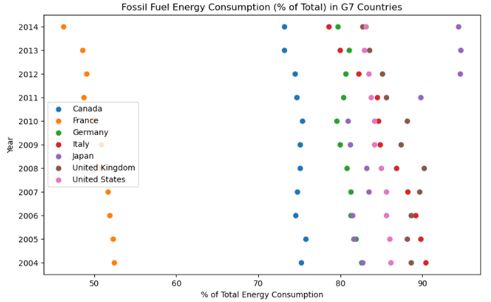

The scatter chart displays the trends of G7 countries' fossil fuel energy usage from 2004 to 2014. Each country is represented by a collection of data points that reflect unique trends in energy usage. Notably, differences in scatterplots between countries reflect different approaches to fossil fuel consumption. The figure efficiently acts as a comparing tool, allowing for the rapid detection of outliers and trends in each country's energy use over an 11-year period.

The visualization provides insightful information about time shifts and probable influencing elements in energy consumption behavior.

A COMBINED BAR GRAPH FOR FOSSIL FUEL CONSUMPTION AMONG G7 COUNTRIES (2004 – 2014

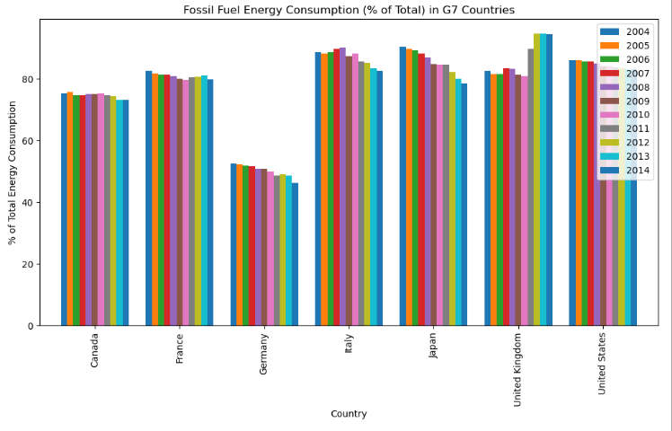

The bar graph displays the share of fossil fuels in the G7 countries' overall energy consumption from 2004 to 2014. According to the graph, Germany and Canada had the lowest fossil fuel energy use over the years, while the United Kingdom continually had the most. Overall, from 2004 to 2014, most G7 countries seem to have slightly reduced their energy use from fossil fuels.

CORRELATION MATRIX FOR THE ANNUAL POPULATION GROWTH ON THE TARGET COUNTRIES (2014)

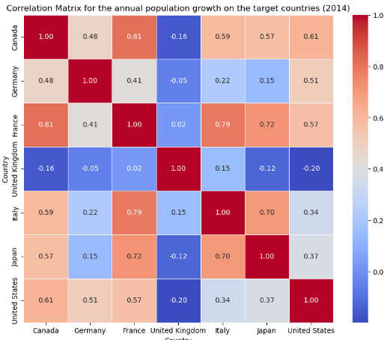 A correlation matrix was created to examine the relationships between the selected countries in the analysis of urban population growth rates for the year 2014. The generated matrix shows intriguing correlational trends in the increase of the urban population. Interestingly, the UK and the USA have negative correlations pointing to diverging patterns, whilst Canada and France have positive correlations reflecting comparable trends. With cooler colors denoting negative correlations and deeper blue colors suggesting stronger positive correlations, the heatmap visualization offers an understandable and straightforward depiction of these connections. Policymakers, researchers, and other stakeholders interested in urban development and planning will find great value in these findings, which are essential for comprehending the similarities and differences in the tendencies of urbanization among these powerful nations.

TRENDS IN ANNUAL URBAN POPULATION GROWTH

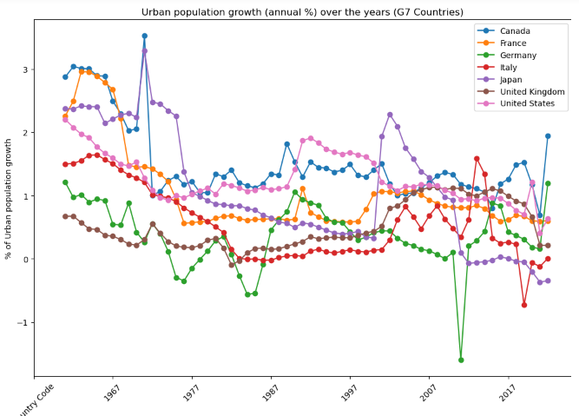

The above line graph shows the G7 countries' yearly percentage growth in urban population for the given time period. A unique line for each nation illustrates the trends in urban population in that nation. The graphic makes it easy to compare the rates of urbanization among the G7 countries, highlighting any possible trends or differences.

A PIE CHART FOR FOSSIL FUEL CONSUMPTION AMONG G7 COUNTRIES

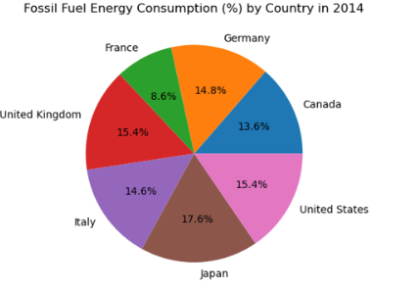

The pie chart shows the distribution of fossil fuel energy consumption among the selected countries in the year 2014. Japan has the highest consumption with 17.6%, followed by the United Kingdom and the United States with 15.4%. At the bottom of the list is France with 8.6%. The rest of the selected countries have a relatively smaller share of consumption.